DIGITAL ELECTRONICS LAB MANUAL
FOR
III SEMESTER B.Tech (ECE)
COURSE CODE: BECCEC307

NAME……………………………………………
REG NO…………………………………………
BATCH…………………………………………..
DEPARTMENT OF ELECTRONICS & COMMUNICATION

PREPARED BY: N.RAJU., M.E.
LECTURER(ECE)
SASTRA UNIVERSITY

List Of Experiments

- Arithmetic Circuit- construction and testing using 74xxICs
        - Half adder and Full adder.
        - Half subtractor and Full subtractor.

- Combinational logic circuit design using 74xxICs.

- Encoders and Decoders.

- Multiplexer and Demultiplexer.

- Study of Arithmetic Logic Unit(ALU) using IC 74181.

- Construction of 1- bit comparator using 74xxICs and study of 4-bit comparator IC 7485.

- code converters – Binary to gray and Gray to binary.

- Verification of basic flip flops using 74xxICs and master- slave JK flip-flop using IC 7476

- Asynchronous counter design and Mod-n counter.

10. 3-Bit synchronous counter design

- Shift register- SIPO/SISO & PISO/PIPO.

- Study of RAM.

The Laboratory Notebook:
Each student must have their own laboratory notebook. All pre-lab exercises and laboratory reports are to be entered into your notebook.
Your notebook must be clearly labelled on the cover with the following information:

Module: Digital Electronics -
Name:
Register no:
Class:
Lab Partner Name:

Introduction
There are 3 hours allocated to a laboratory session in Digital Electronics. It is a necessary part of the course at which attendance is compulsory.
Here are some guidelines to help you perform the experiments and to submit the reports:
- Read all instructions carefully and carry them all out.
- Ask a demonstrator if you are unsure of anything.
- Record actual results (comment on them if they are unexpected!)
- Write up full and suitable conclusions for each experiment.
- If you have any doubt about the safety of any procedure, contact the demonstrator beforehand.
- THINK about what you are doing!

The Breadboard
The breadboard consists of two terminal strips and two bus strips (often broken in the centre). Each bus strip has two rows of contacts. Each of the two rows of contacts are a node. That is, each contact along a row on a bus strip is connected together (inside the breadboard). Bus strips are used primarily for power supply connections, but are also used for any node requiring a large number of connections. Each terminal strip has 60 rows and 5 columns of contacts on each side of the centre gap. Each row of 5 contacts is a node.
You will build your circuits on the terminal strips by inserting the leads of circuit components into the contact receptacles and making connections with 22-26 gauge wire. There are wire cutter/strippers and a spool of wire in the lab. It is a good practice to wire +5V and 0V power supply connections to separate bus strips.
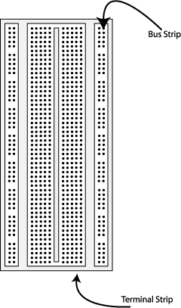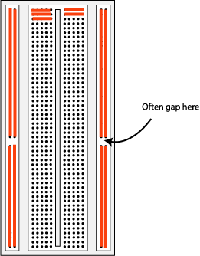
Fig 1. The breadboard. The lines indicate connected holes.
The 5V supply MUST NOT BE EXCEEDED since this will damage the ICs (Integrated circuits) used during the experiments. Incorrect connection of power to the ICs could result in them exploding or becoming very hot - with the possible serious injury occurring to the people working on the experiment! Ensure that the power supply polarity and all components and connections are correct before switching on power .

Building the Circuit
Throughout these experiments we will use TTL chips to build circuits. The steps for wiring a circuit should be completed in the order described below:
- Turn the power (Trainer Kit) off before you build anything!
- Make sure the power is off before you build anything!
- Connect the +5V and ground (GND) leads of the power supply to the power and ground bus strips on your breadboard.
- Plug the chips you will be using into the breadboard. Point all the chips in the same direction with pin 1 at the upper-left corner. (Pin 1 is often identified by a dot or a notch next to it on the chip package)
- Connect +5V and GND pins of each chip to the power and ground bus strips on the breadboard.
- Select a connection on your schematic and place a piece of hook-up wire between corresponding pins of the chips on your breadboard. It is better to make the short connections before the longer ones. Mark each connection on your schematic as you go, so as not to try to make the same connection again at a later stage.
- Get one of your group members to check the connections, before you turn the power on.
- If an error is made and is not spotted before you turn the power on. Turn the power off immediately before you begin to rewire the circuit.
- At the end of the laboratory session, collect you hook-up wires, chips and all equipment and return them to the demonstrator.
- Tidy the area that you were working in and leave it in the same condition as it was before you started.

Common Causes of Problems
- Not connecting the ground and/or power pins for all chips.
- Not turning on the power supply before checking the operation of the circuit.
- Leaving out wires.
- Plugging wires into the wrong holes.
- Driving a single gate input with the outputs of two or more gates
- Modifying the circuit with the power on.
In all experiments, you will be expected to obtain all instruments, leads, components at the start of the experiment and return them to their proper place after you have finished the experiment. Please inform the demonstrator or technician if you locate faulty equipment. If you damage a chip, inform a demonstrator, don't put it back in the box of chips for somebody else to use.
If you locate any errors in this manual, please e-mail:-
nraju4u@sify.com

Example Implementation of a Logic Circuit
Build a circuit to implement the Boolean function F = /(/A./B), please note that the notation /A refers to . You should use that notation during the write-up of your laboratory experiments.
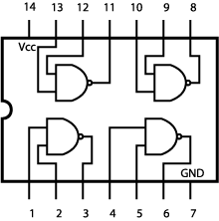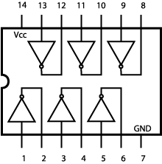
Quad 2 Input 7400 Hex 7404 Inverter
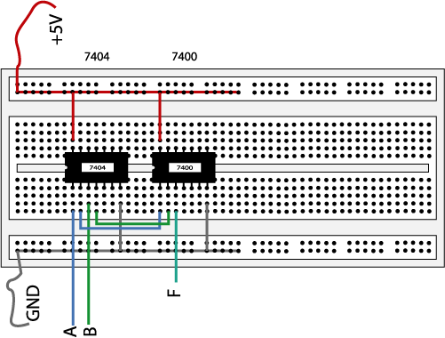
Fig 2. The complete designed and connected circuit
Sometimes the chip manufacturer may denote the first pin by a small indented circle above the first pin of the chip. Place your chips in the same direction, to save confusion at a later stage. Remember that you must connect power to the chips to get them to work.

Useful IC Pin details

7400(NAND)
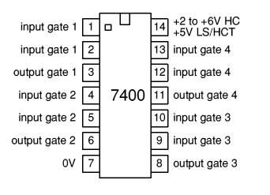
7402(NOR)
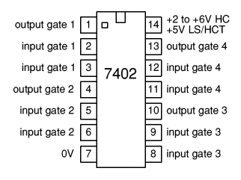
7404(NOT) 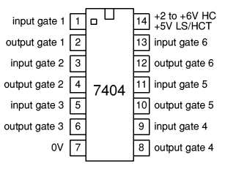
7408(AND)

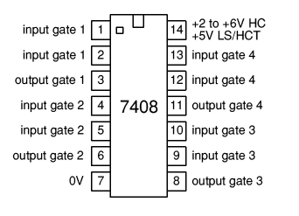

7411(3-i/p AND)
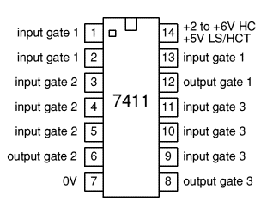
7432(OR)
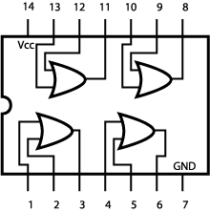

7486(EX-OR)
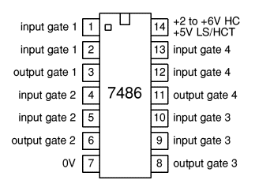
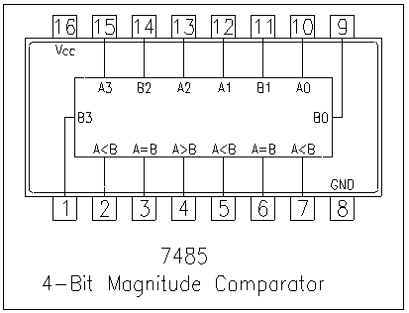

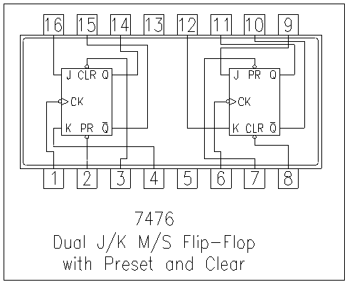

7410(3-i/p NAND)
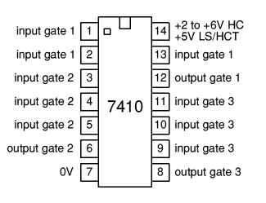
7420(4-i/p NAND)

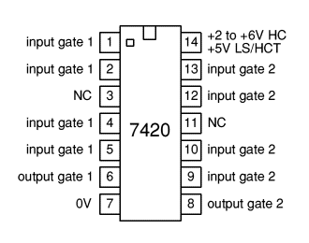

Experiment No: Date: __/__/____

HALF/FULL ADDER & HALF/FULL SUBTRACTOR

Aim: - To realize half/full adder and half/full subtractor.
Using X-OR and basic gates

Apparatus Required: -
IC 7486, IC 7432, IC 7408, IC 7400, etc.

Procedure: -

1. Verify the gates.
2. Make the connections as per the circuit diagram.
3. Switch on VCC and apply various combinations of input according to
truth table.
4. Note down the output readings for half/full adder and half/full
subtractor sum/difference and the carry/borrow bit for different
combinations of inputs.

Circuit Diagram:-

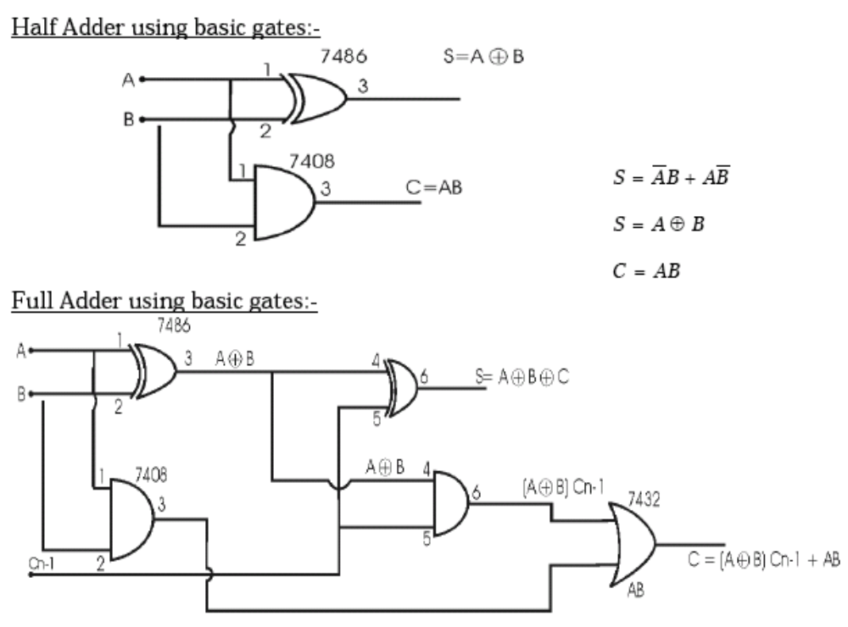
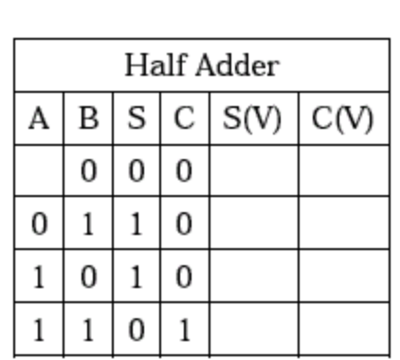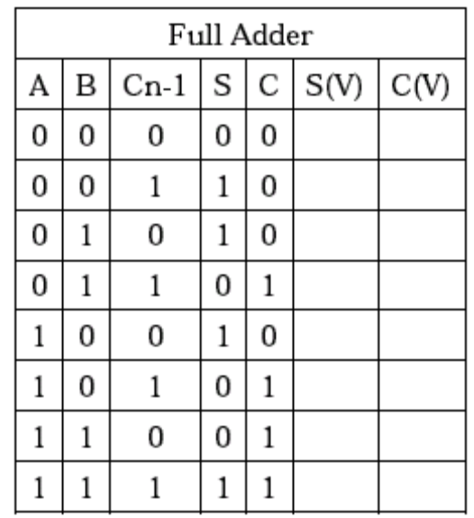

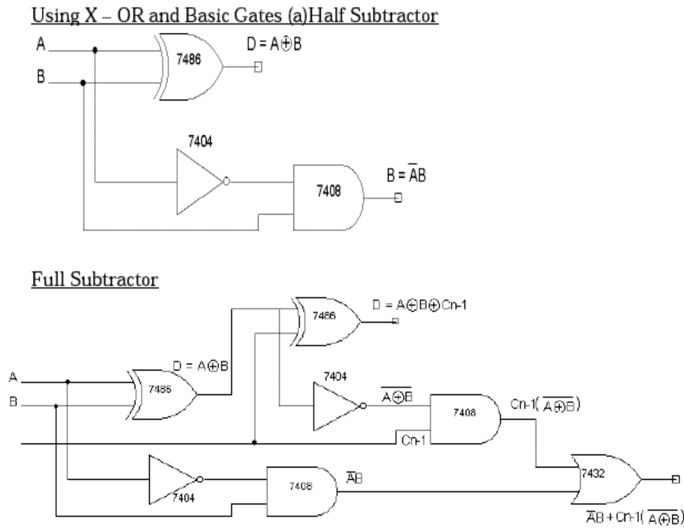

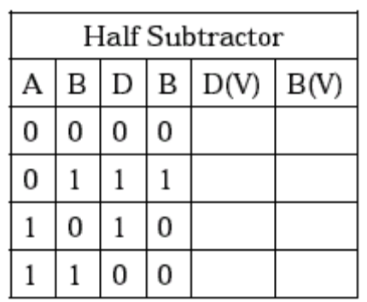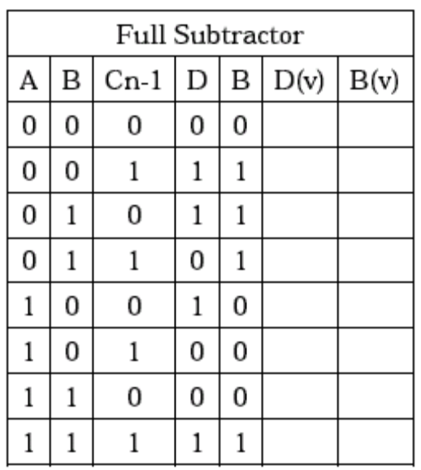

Conclusion: -

…………………………………………..
Signature of the staff in charge

Experiment No: Date: __/__/____

COMBINATIONAL LOGIC DESIGN USING 74xx ICs

Aim: A warning buzzer is to sound when the following conditions apply:

- Switches A, B, C are on.
- Switches A and B are on but switch C is off.
- Switches A and C are on but switch B is off.
- Switches C and B are on but switch A is off.

Draw a truth table for this situation and obtain a Boolean expression for it. Minimize this expression and draw a logic diagram using only a) NAND b) NOR gates. If the delay of a NAND gate is 15ns and that of a NOR gate is 12ns, which implementation is faster.

Pre-Laboratory :-
There are two tasks that you must perform prior to sitting this laboratory:
- Understand the design problem given to you.
- Draw up the truth tables and logic diagram for the design .

Apparatus Required: -

Procedure: -

1. Verify the gates.
2. Make the connections as per the circuit diagram.
3. Switch on VCC and apply various combinations of input according to
truth table.
4. Note down the output readings combinations of inputs.

Circuit Diagram& Truth table :-

Conclusion: -

…………………………………………..
Signature of the staff in charge

Experiment No: Date: __/__/____

MUX/DEMUX USING 74153 & 74139

Aim: - To verify the truth table of MUX and DEMUX .

Apparatus Required: -

IC 74153, IC 74139 etc.

Procedure: - (IC 74153)

1. The Pin [16] is connected to + Vcc.
2. Pin [8] is connected to ground.
3. The inputs are applied either to ‘A’ input or ‘B’ input.
4. If MUX ‘A’ has to be initialized, Ea is made low and if MUX ‘B’
has to be initialized, Eb is made low.
5. Based on the selection lines one of the inputs will be selected at the
output and thus verify the truth table

Procedure: - (IC 74139)
1. The inputs are applied to either ‘a’ input or ‘b’ input
2. The demux is activated by making Ea low and Eb low.
3. Verify the truth table .

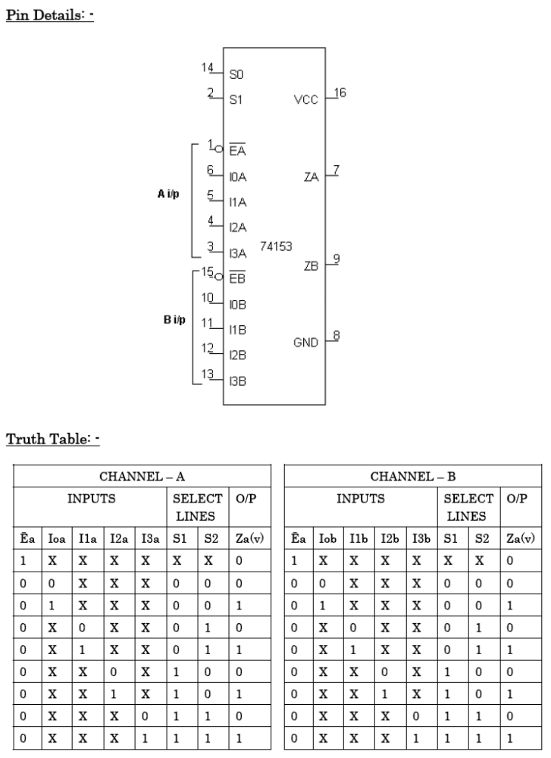

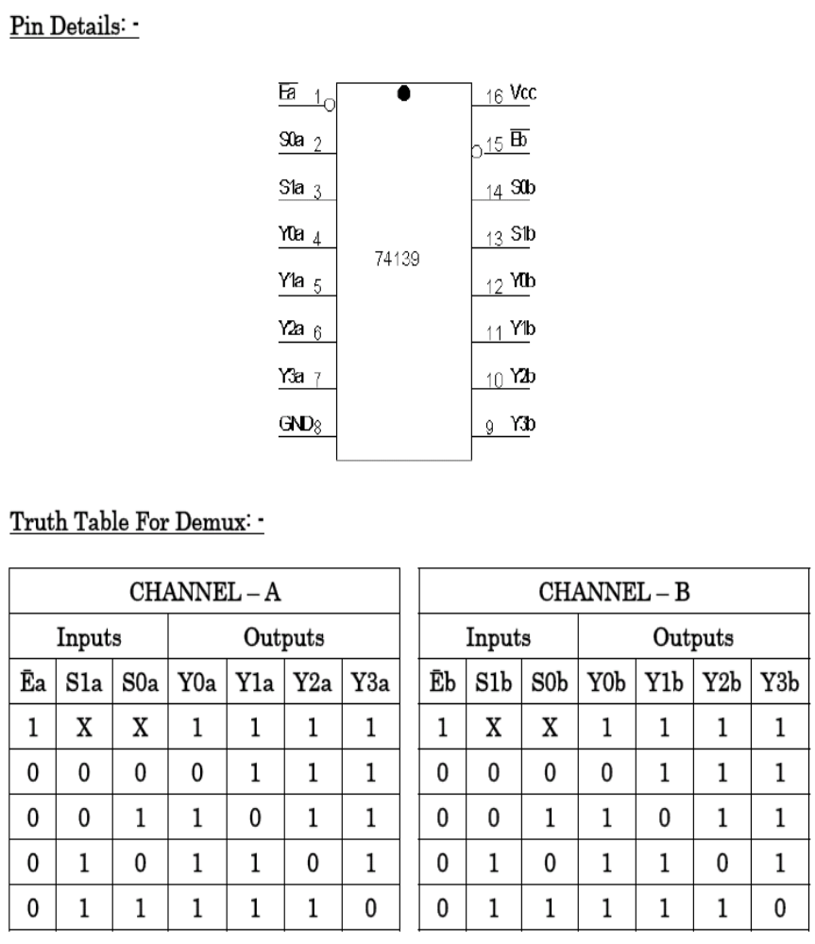

Conclusion: -

…………………………………………..
Signature of the staff in charge

Experiment No: Date: __/__/____

BINARY TO GRAY AND GRAY TO BINARY
CONVERSION

Aim: - To convert given binary numbers to gray codes.

Apparatus Required: -
IC 7486, etc

Procedure: -

1. The circuit connections are made as shown in fig.
2. Pin (14) is connected to +Vcc and Pin (7) to ground.
3. In the case of binary to gray conversion, the inputs B0, B1, B2 and B3 are given at respective pins and outputs G0, G1, G2, G3 are taken for all the 16 combinations of the input.
4. In the case of gray to binary conversion, the inputs G0, G1, G2 and G3 are given at respective pins and outputs B0, B1, B2, and B3 are taken for all the 16 combinations of inputs.
5. The values of the outputs are tabulated.

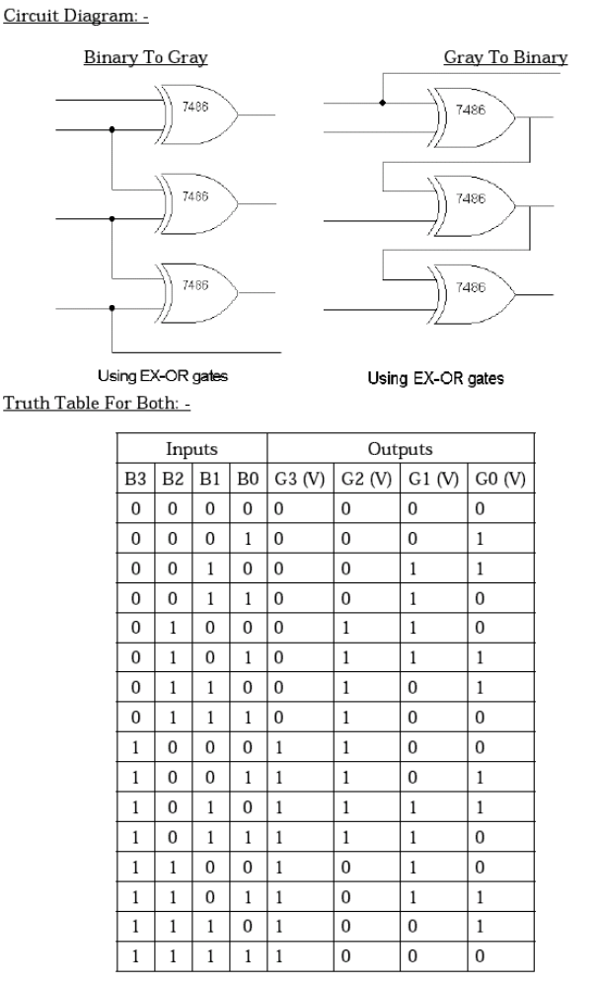

Conclusion: -

…………………………………………..
Signature of the staff in charge

Experiment No: Date: __/__/____

COMPARATORS

Aim: - To verify the truth table of one bit and four bit comparators using
logic Gates and IC 7485

Apparatus Required: -

IC 7486, IC 7404, IC 7408, IC 7485etc.

Procedure: -

1. Verify the gates.
2. Make the connections as per the circuit diagram.
3. Switch on Vcc.
4. Applying i/p and Check for the outputs.
5. The readings of outputs should be tabulated .

Circuit diagram& truth tables:-

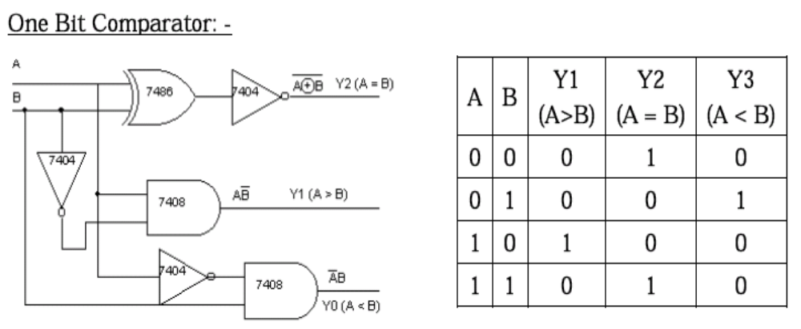

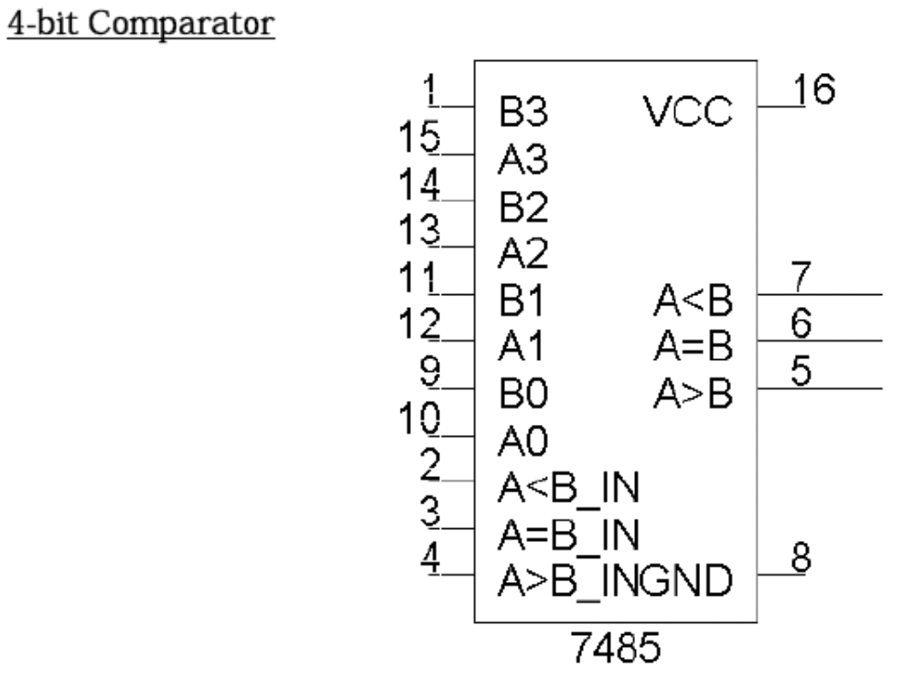
Tabular column :-

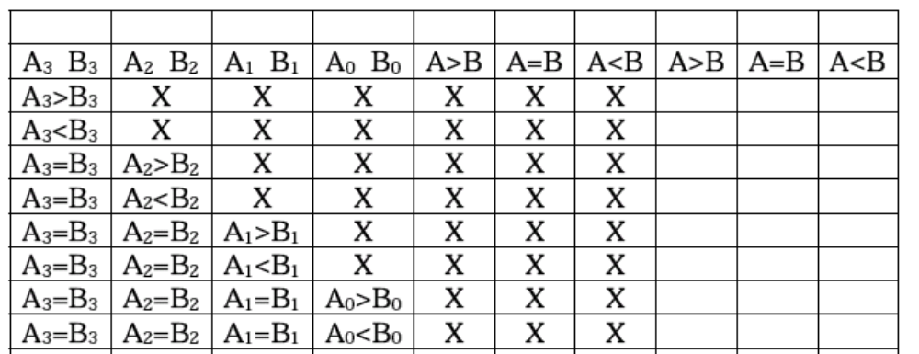

Conclusion: -

…………………………………………..
Signature of the staff in charge

Experiment No: Date: __/__/____

RANDOM ACESS MEMORY(RAM)

Aim: - To conduct an experiment to store a set of data in a RAM using IC 7489 starting from location ------- to location-------- and retrieve the same data.

Apparatus Required: -

IC 7489, etc.

Procedure: -

1. Circuits connections are made to the appropriate pins of IC 7489
2. First you have to write the data and then read the data, for writing data make WE to low and ME input to low
3. For a 4-bit data select any address input from A0 to A9. for ex, select A3 to A0 and connect the data inputs/ outputs i.e., I/O4 – I/O1
4. Write a 4-bit data of your choice in each of the required address inputs or memory locations
5. By doing the above steps 2, 3 and 4 the data will be stored in the memory location
6. For reading data
a. make WE to high and ME input to low
b. disconnect the data inputs I/O4 – I/O1 from input lines and connect them to output lines to read the data
c. and then give the address inputs of the data you have stored and observe the outputs through I/O4 – I/O1.

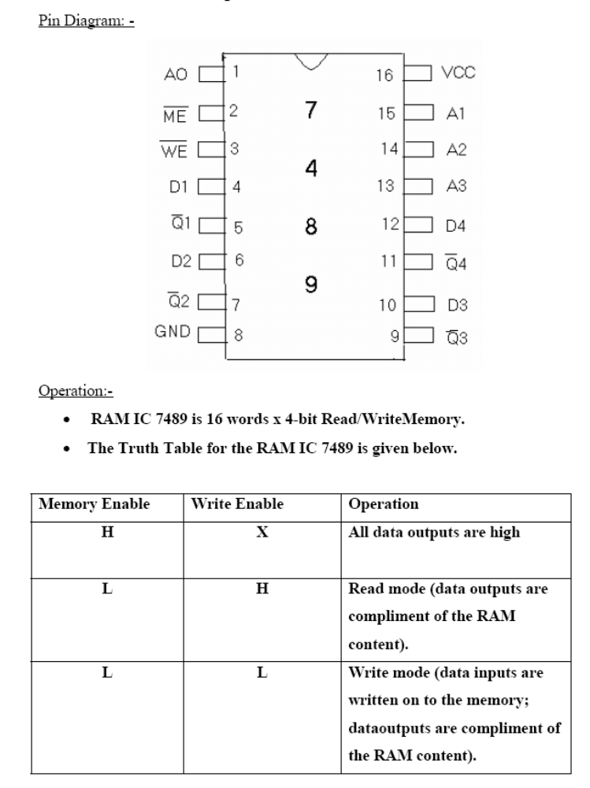

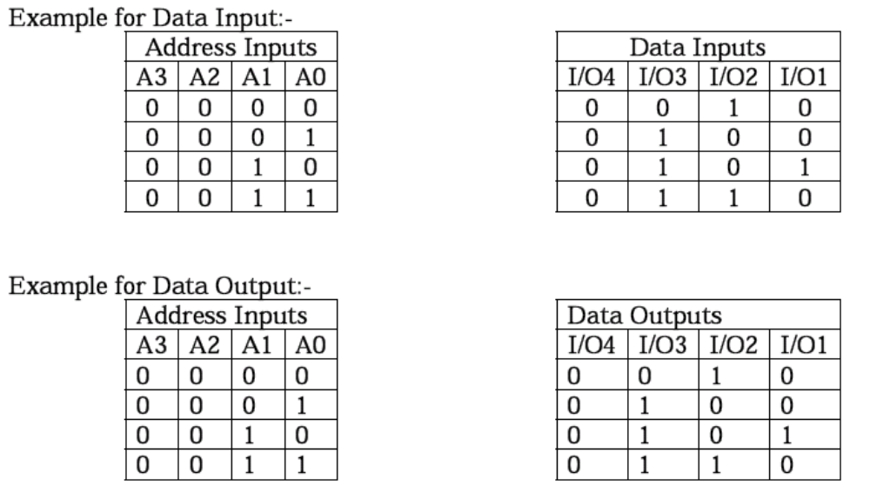

Conclusion:-

………………………………………….
Signature of the staff in charge

Experiment No: Date: __/__/____

SHIFT REGISTER

Aim:- To study shift register using IC 7495 in all its modes i.e.
SIPO/SISO, PISO/PIPO.

Apparatus Required: -

IC 7495, etc.

Procedure:-

Serial In Parallel Out(SIPO):-

1. Connections are made as per circuit diagram.
2. Apply the data at serial i/p
3. Apply one clock pulse at clock 1 (Right Shift) observe this data at QA.
4. Apply the next data at serial i/p.
5. Apply one clock pulse at clock 2, observe that the data on QA will shift to
QB and the new data applied will appear at QA.
6. Repeat steps 2 and 3 till all the 4 bits data are entered one by one into the
shift register.
Serial In Serial Out(SISO):-

1. Connections are made as per circuit diagram.
2. Load the shift register with 4 bits of data one by one serially.
3. At the end of 4th clock pulse the first data ‘d0’ appears at QD.
4. Apply another clock pulse; the second data ‘d1’ appears at QD.
5. Apply another clock pulse; the third data appears at QD.
6. Application of next clock pulse will enable the 4th data ‘d3’ to appear at
QD. Thus the data applied serially at the input comes out serially at QD

Parallel In Serial Out (PISO):-

1. Connections are made as per circuit diagram.
2. Apply the desired 4 bit data at A, B, C and D.
3. Keeping the mode control M=1 apply one clock pulse. The data applied at
A, B, C and D will appear at QA, QB, QC and QD respectively.
4. Now mode control M=0. Apply clock pulses one by one and observe the
Data coming out serially at QD

Parallel In Parallel Out (PIPO):-

1. Connections are made as per circuit diagram.
2. Apply the 4 bit data at A, B, C and D.
3. Apply one clock pulse at Clock 2 (Note: Mode control M=1).
4. The 4 bit data at A, B, C and D appears at QA, QB, QC and QD
respectively.

Circuit diagram :-

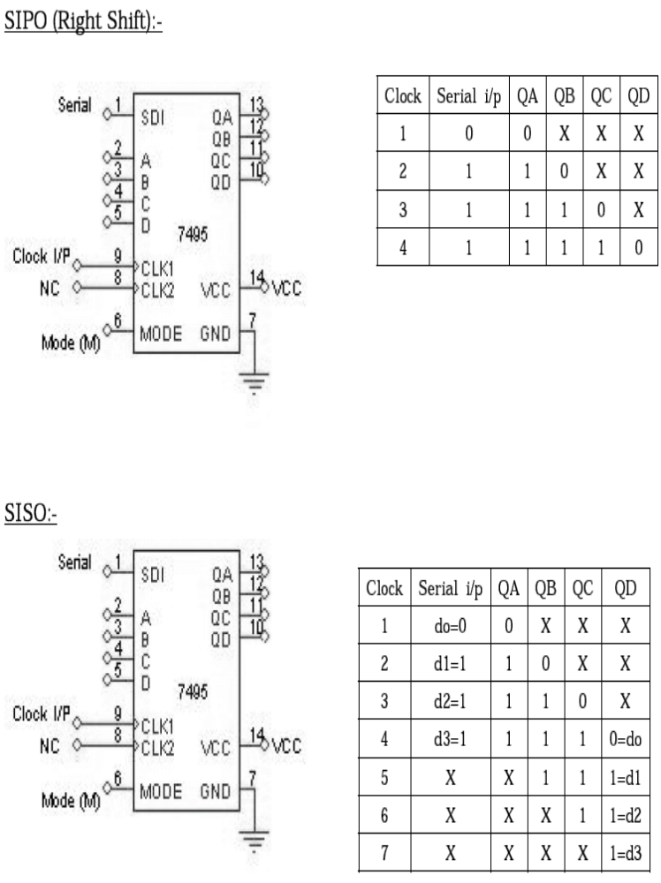

PISO:-
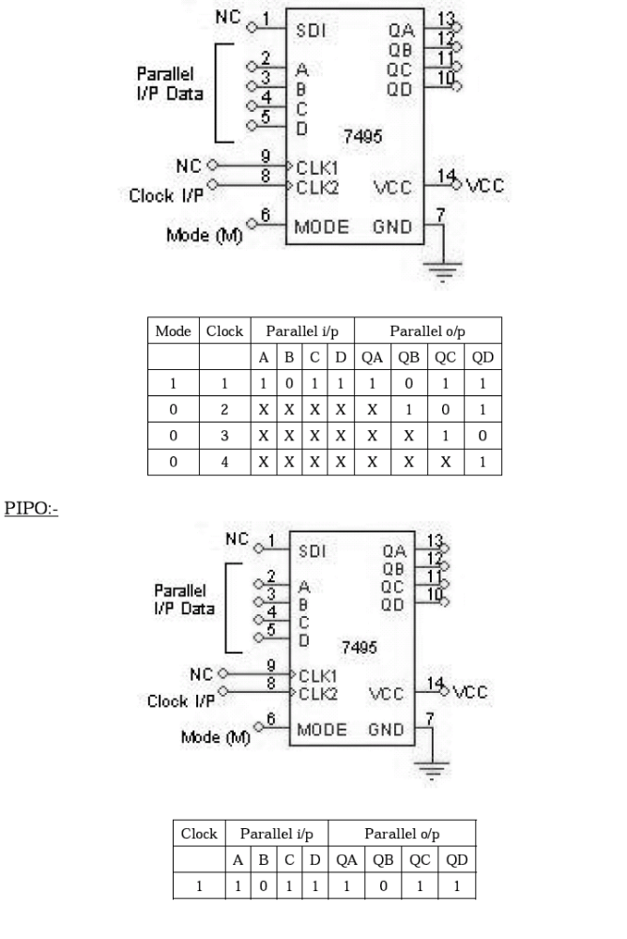

Conclusion:-

………………………………………….
Signature of the staff in charge

Experiment No: Date: __/__/____

ARITHMETIC LOGIC UNIT

Aim: - To verify the Function table of 4 bit ALU( IC 74181.

Apparatus Required: -

IC 74181, etc.

Procedure: -

1. Connections are made as shown in the Circuit diagram.
2. Change the values of the inputs and verify at least 5 functions
given in the function table.
Pin detail & Function table:-

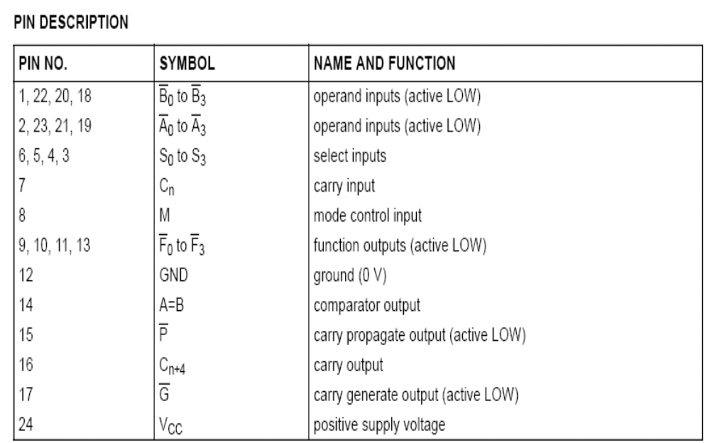

IC 74181

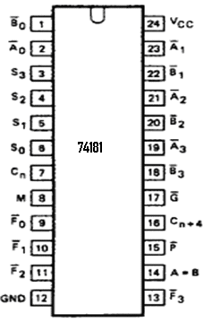
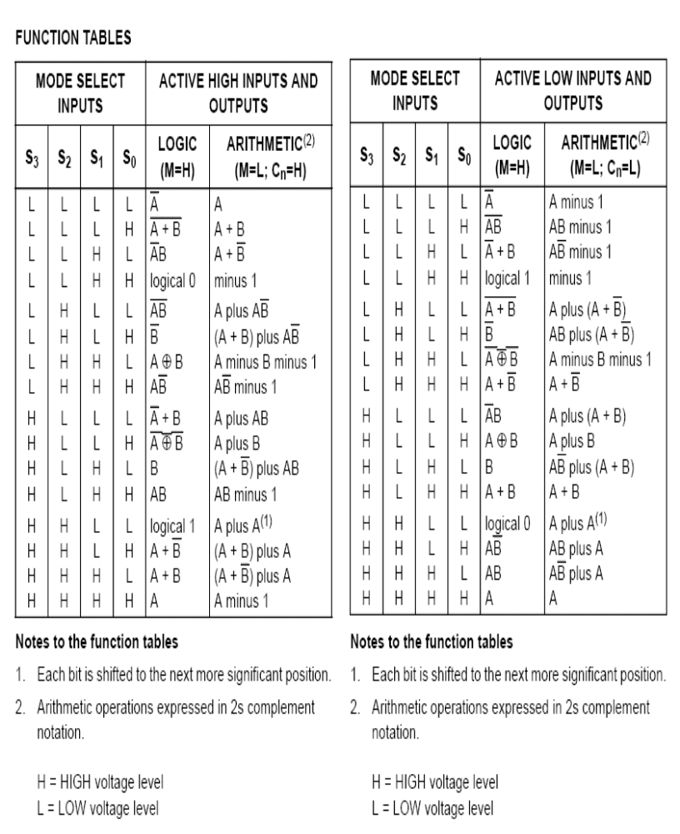

Conclusion:-

………………………………………….
Signature of the staff in charge

Experiment No: Date: __/__/____

ASYNCHRONOUS COUNTER DESIGN AND MOD-N COUNTER

Aim: - Realization of 3-bit Asynchronous counter and Mod-N counter
design .
.

Apparatus Required: -

IC 7408, IC 7476, IC 7400, IC 7432 etc.

Procedure: -

1. Connections are made as per circuit diagram.
2. Clock pulses are applied one by one at the clock I/P and the O/P is
observed at QA, QB & QC for IC 7476.
3. Verify the Truth table .

Circuit Diagram:
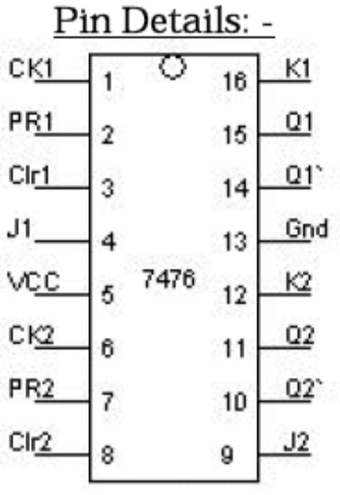
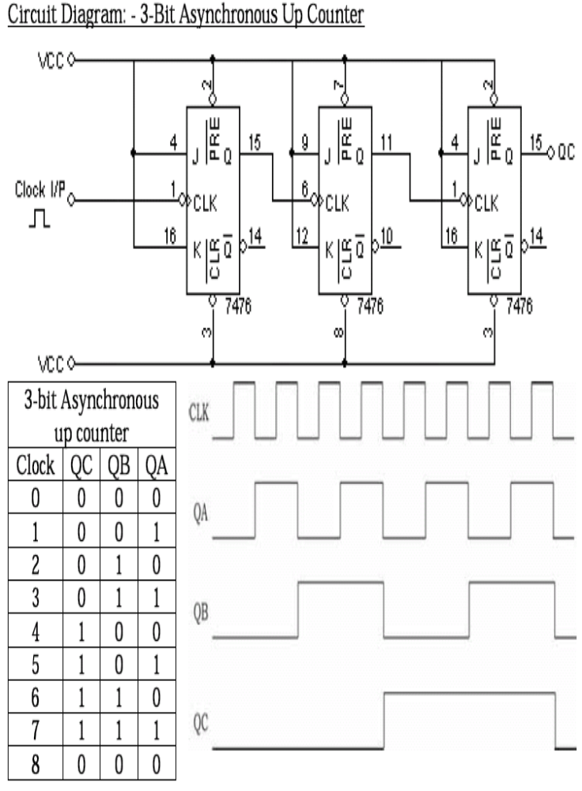
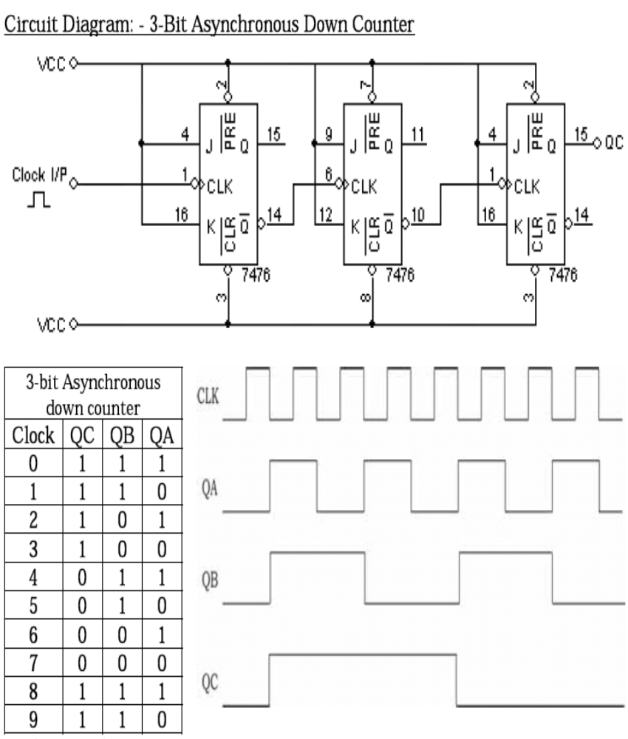

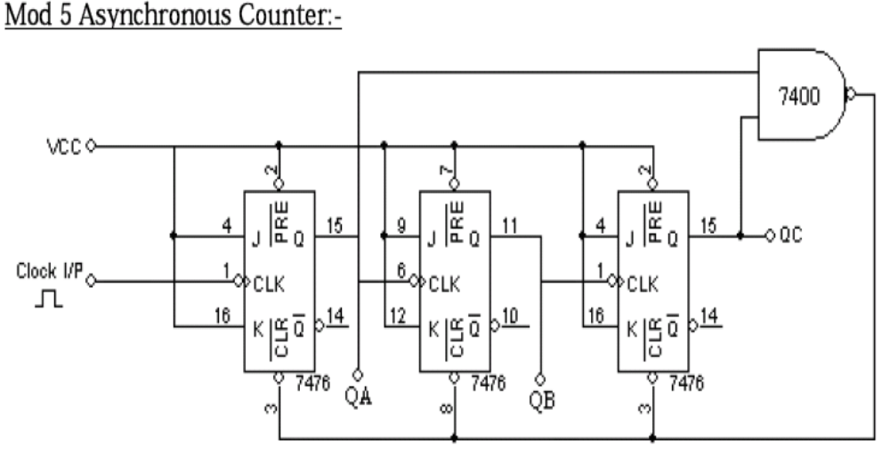
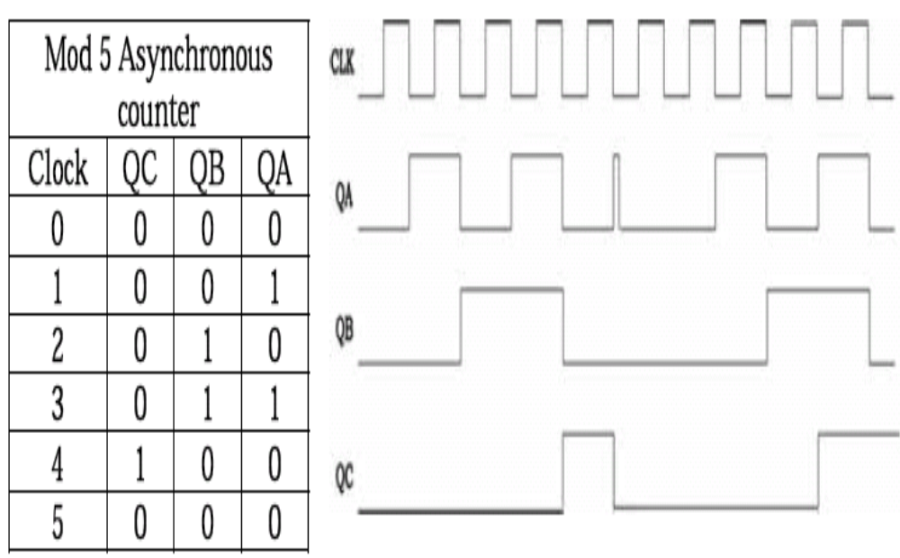

Conclusion:-

………………………………………….
Signature of the staff in charge

Experiment No: Date: __/__/____

SYNCHRONOUS COUNTER DESIGN

Aim: - Realization of 3-bit synchronous counter design.
.

Apparatus Required: -

IC 7408, IC 7476, IC 7400, IC 7432 etc.

Procedure: -

1. Connections are made as per circuit diagram.
2. Clock pulses are applied one by one at the clock I/P and the O/P is
observed at QA, QB & QC for IC 7476.
3. Verify the Truth table .

Circuit Diagram& Truth table:

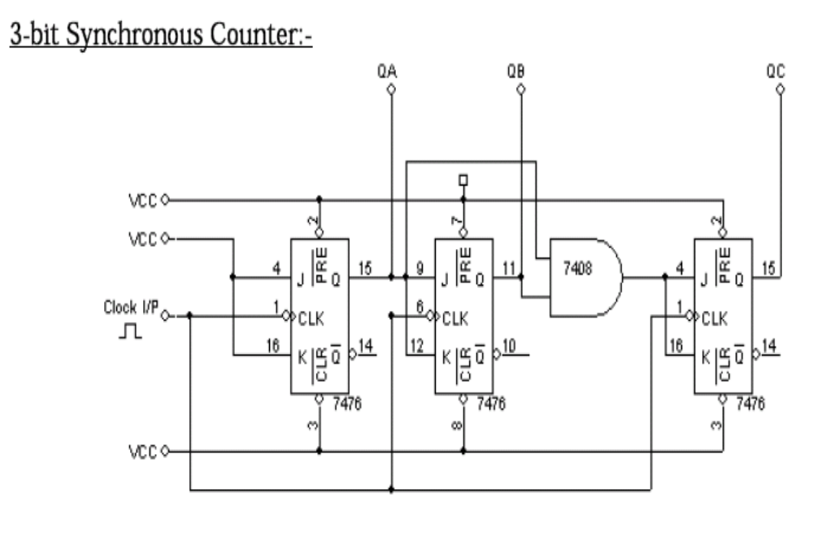
Truth table :-
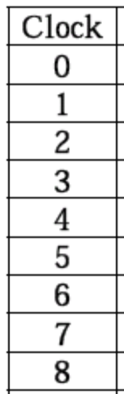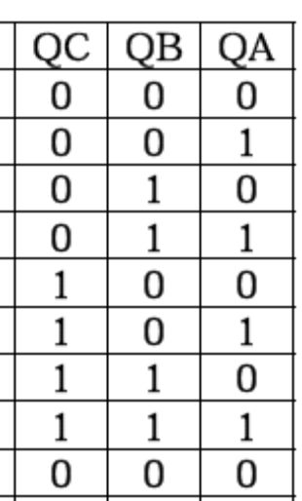

Conclusion:-

………………………………………….
Signature of the staff in charge

Experiment No: Date: __/__/____

FLIP-FLOP

Aim:- Truth table verification of Flip-Flops: (i) RS-Type
(ii) D- Type
(iii) T- Type.
(iv)JK-Type

Apparatus Required: -

IC 7400,IC 7404 etc.

Procedure: -

1. Connections are made as per circuit diagram.
2. Verify the truth table for various combinations of inputs.

Circuit Diagram& Truth table:

i)RS Flip-Flop

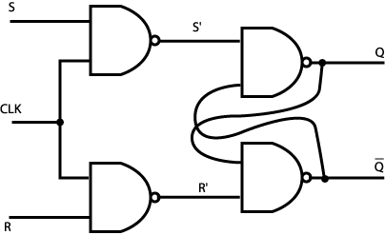

Qn | /Qn | R | S | Qn+1 | /Qn+1
0 | 1 | 0 | 0
1 | 0 | 0 | 0
0 | 1 | 0 | 1
1 | 0 | 0 | 1
0 | 1 | 1 | 0
1 | 0 | 1 | 0
0 | 1 | 1 | 1
1 | 0 | 1 | 1

ii) D Flip-Flop

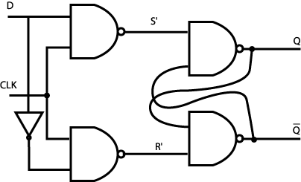

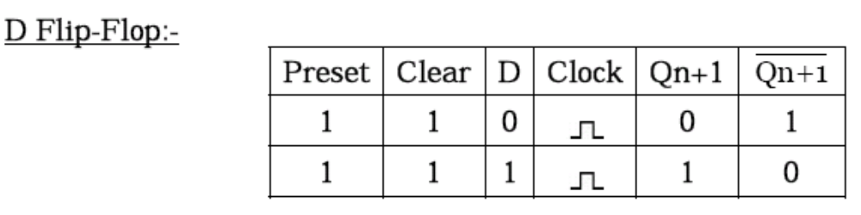

iii) T Flip-flop

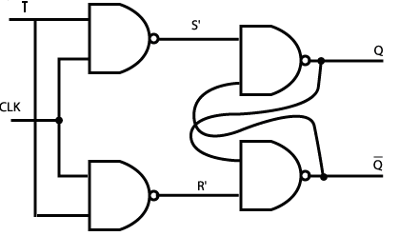

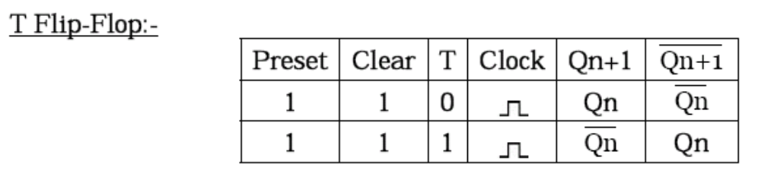

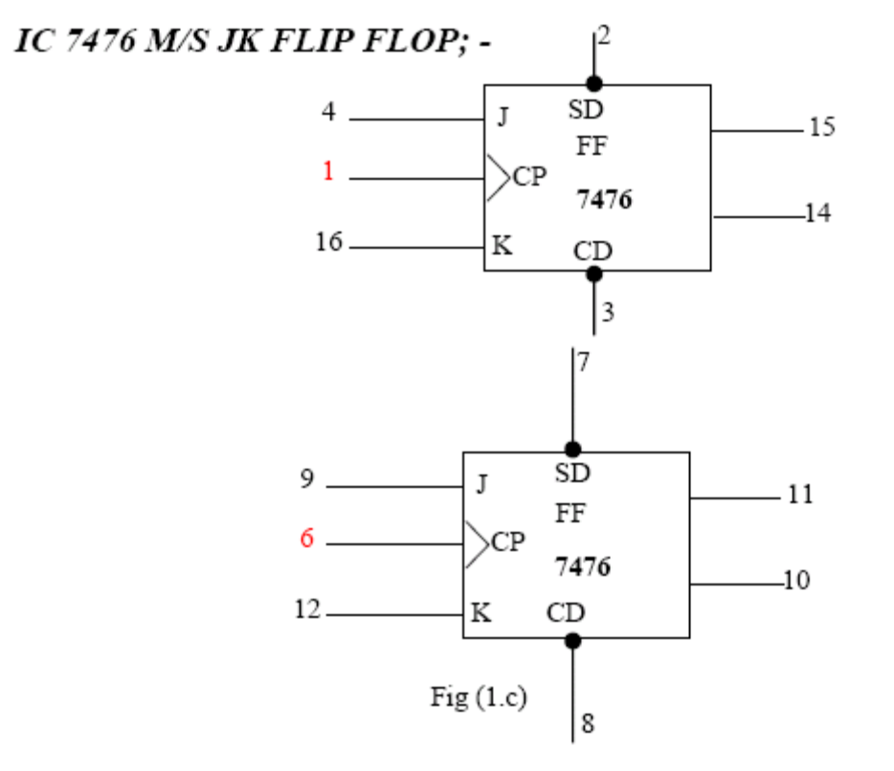
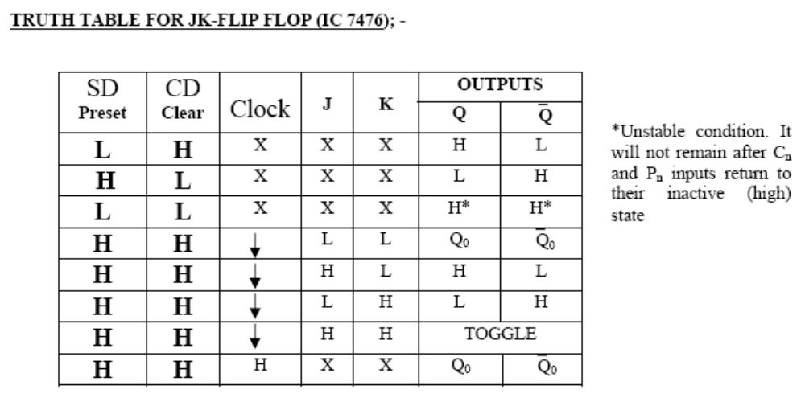

Conclusion:-

………………………………………….
Signature of the staff in charge

Experiment No: Date: __/__/____

ENCODER AND DECODER

Aim: - Realization of 2:4 decoder and 4:2 encoder design.
.

Pre-Laboratory :-
There are two tasks that you must perform prior to sitting this laboratory:
- Understand the design problem given to you.
- Draw up the truth tables and logic diagram for the design .

Apparatus Required: -

Procedure: -

1. Verify the gates.
2. Make the connections as per the circuit diagram.
3. Switch on VCC and apply various combinations of input according to
truth table.
4. Note down the output readings combinations of inputs.

Circuit Diagram& Truth table :-

Conclusion: -

…………………………………………..
Signature of the staff in charge

